**Project 2 Report**

Lai Chit Kwok

301592147

School of Computing Science, Simon Fraser University

CMPT365: Multimedia Systems

Dr. Jiangchuan Liu

November 1, 2024

**Project Environment**

The program is written using Python 3.12 and ran on Windows 11. For external libraries, I used the following:

1. NumPy (numpy): It is utilized for efficient numerical computations and array manipulations, especially with large datasets like images. NumPy provides functions for mathematical operations, which are essential for processing pixel data in image effects.
2. SciPy (scipy): Specifically, the scipy.signal module is used for its convolve2d function, which is crucial for implementing the Gaussian blur in the unsharp masking process. This function allows for efficient 2D convolution operations on image data.
3. Tkinter (tkinter): This is Python's standard GUI (Graphical User Interface) package. It's used to create the application's interface, including file dialogs, menus, windows, and interactive sliders. Tkinter provides the following components used in the program:
   * filedialog: For opening file selection dialogs
   * Menu: To create the application's menu bar
   * Toplevel: For creating secondary windows, such as for parameter adjustment
   * Scale: To implement interactive sliders for adjusting effect parameters

The combination of these libraries allows for efficient image processing operations (NumPy and SciPy) while providing a user-friendly interface (Tkinter) for interacting with the application and adjusting image effects in real-time.

**Screenshots**

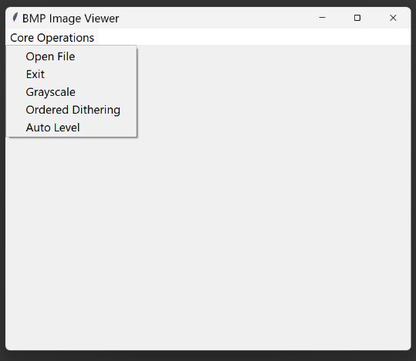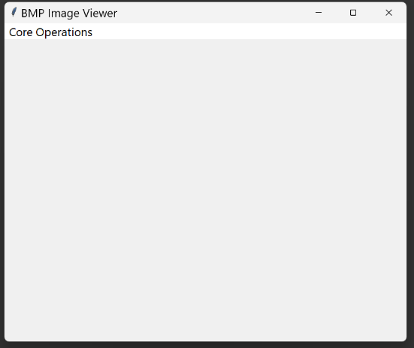**Initial state**

Figure 1 Initial state, with no image selected

**Photo selected, without any transformation applied yet**

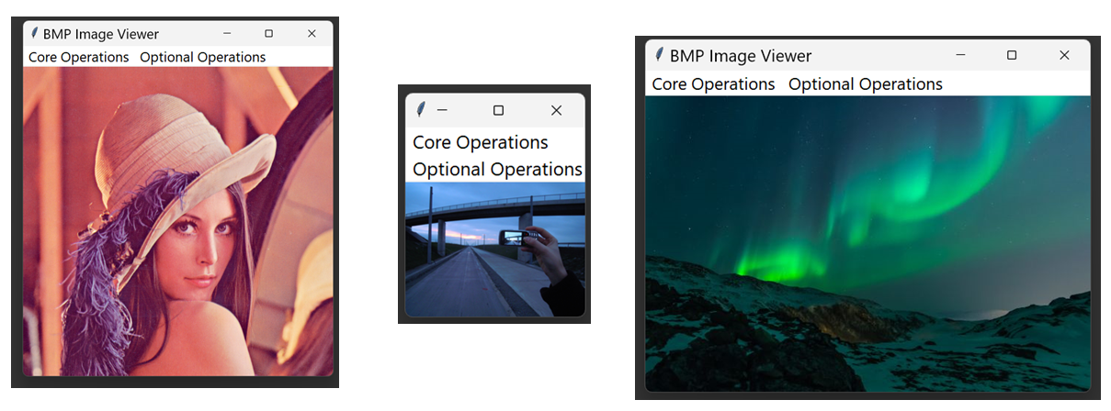

Figure 2 Samples photo selected, without applied transformation

**Core operations (Transformations)**

*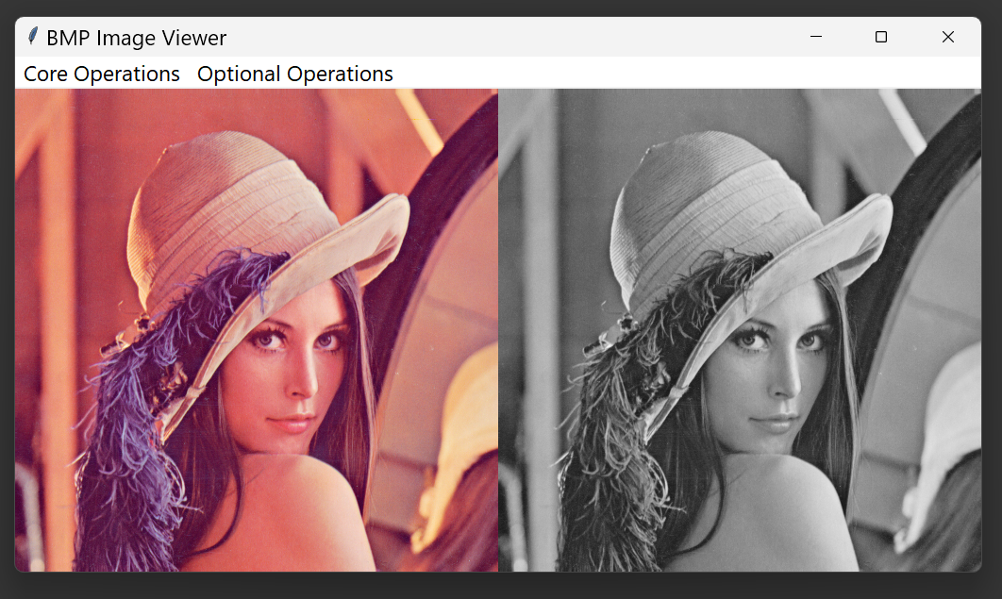****Greyscale***

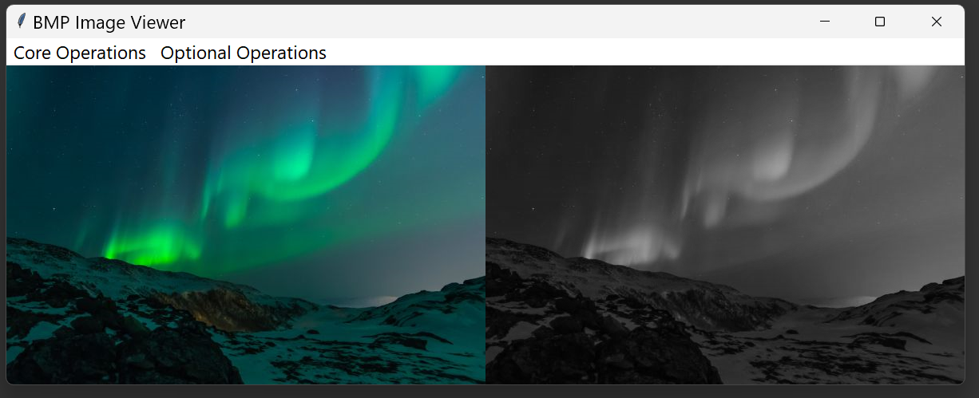

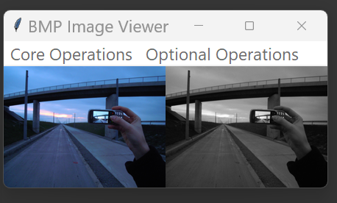

Figure 3 Sample Images After Greyscale

***Ordered dithering***

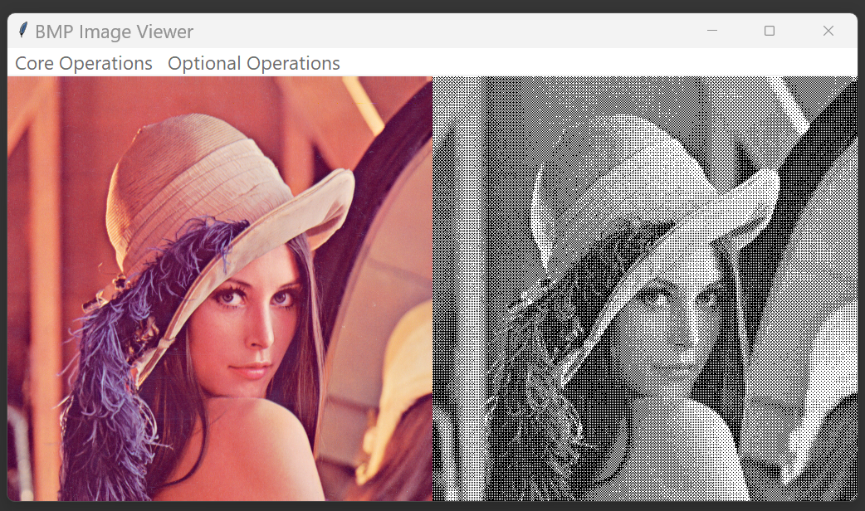

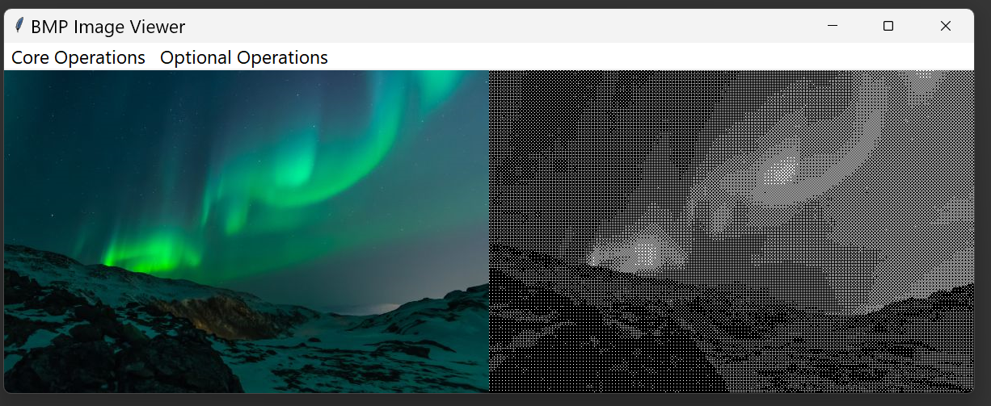

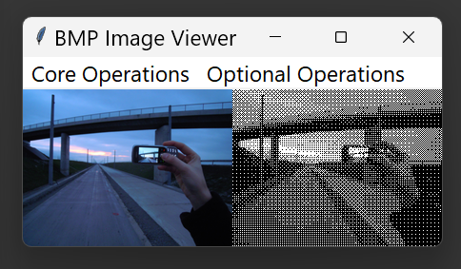

Figure 4 Sample Images After Ordered Dithering

***Auto level***

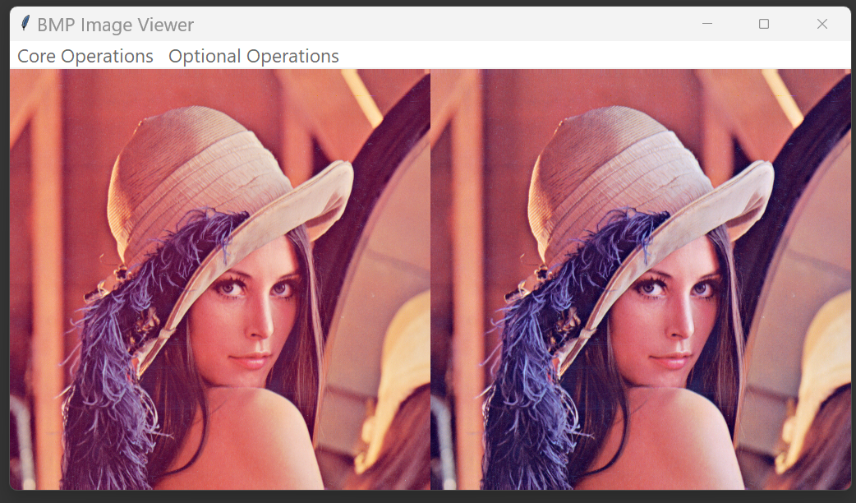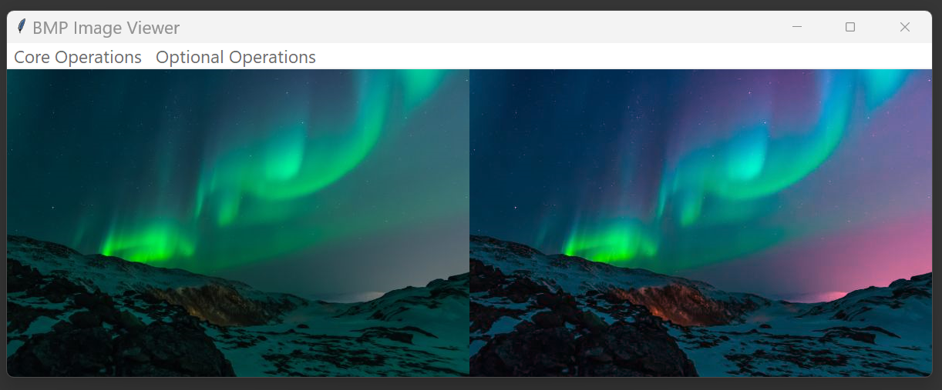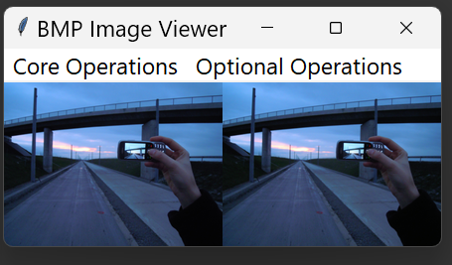

Figure 5 Sample Images After Auto Level

**Optional operations (Transformations)**

***Invert Colors***

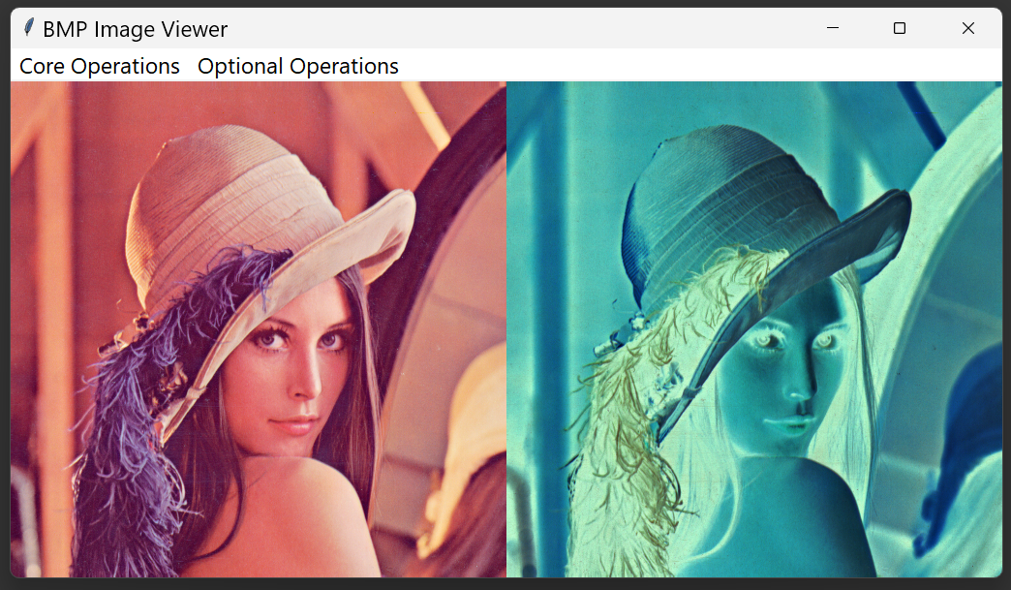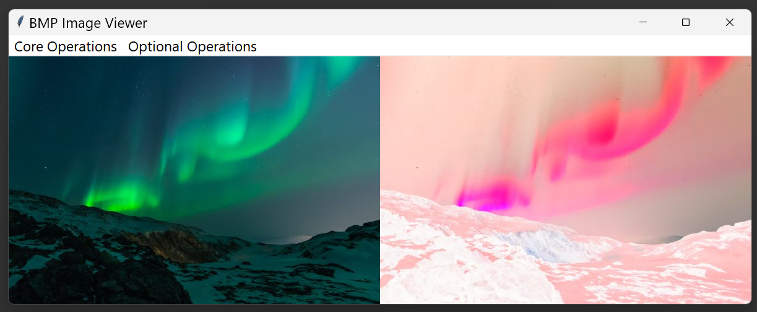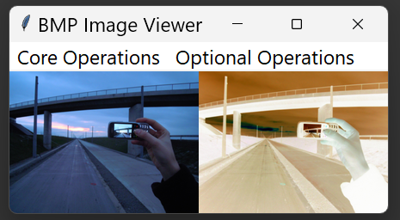

Figure 6 Sample Images After Invert Colors

***Sepia Tone***

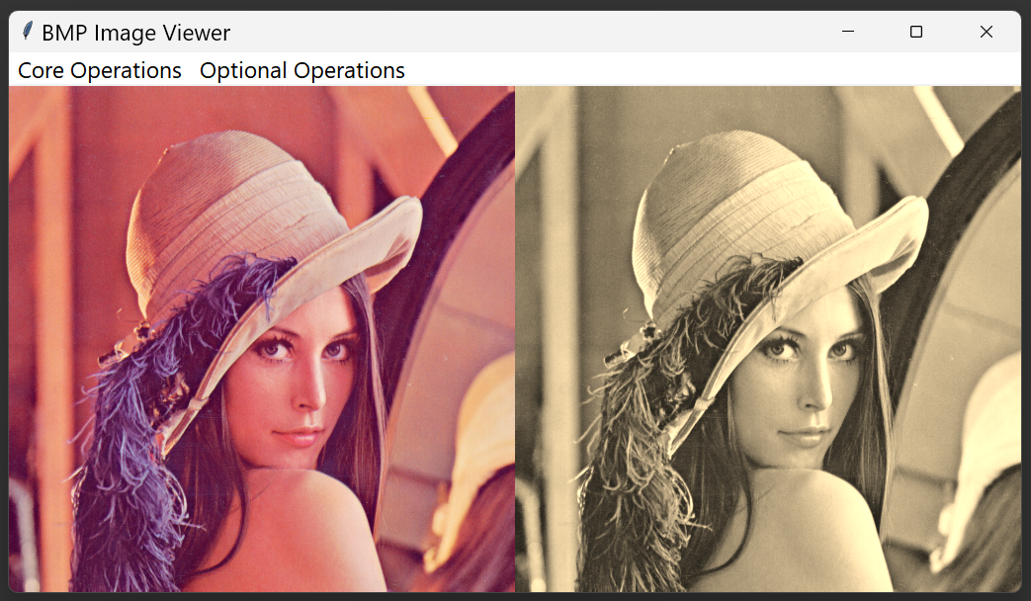

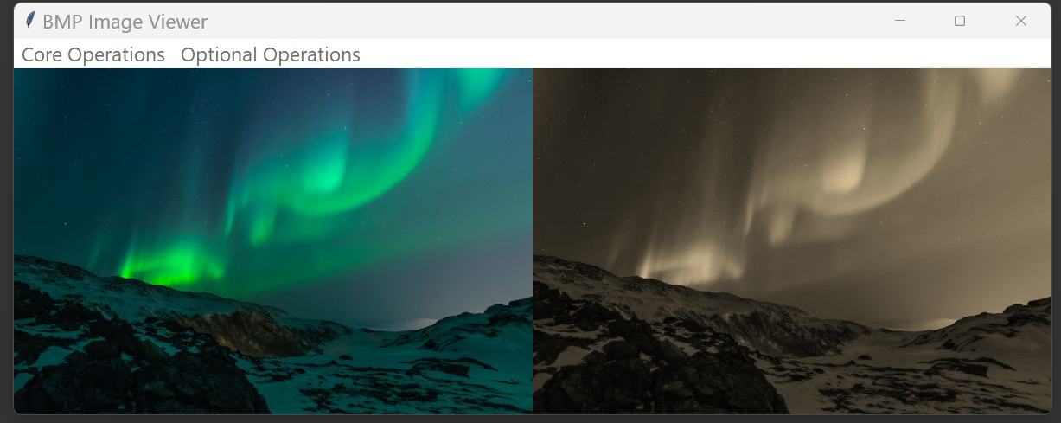

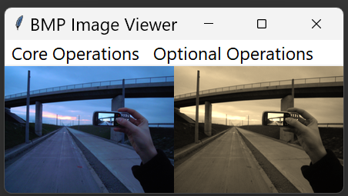

Figure 7 Sample Images After Sapia Tone

***Fisheye Effect***

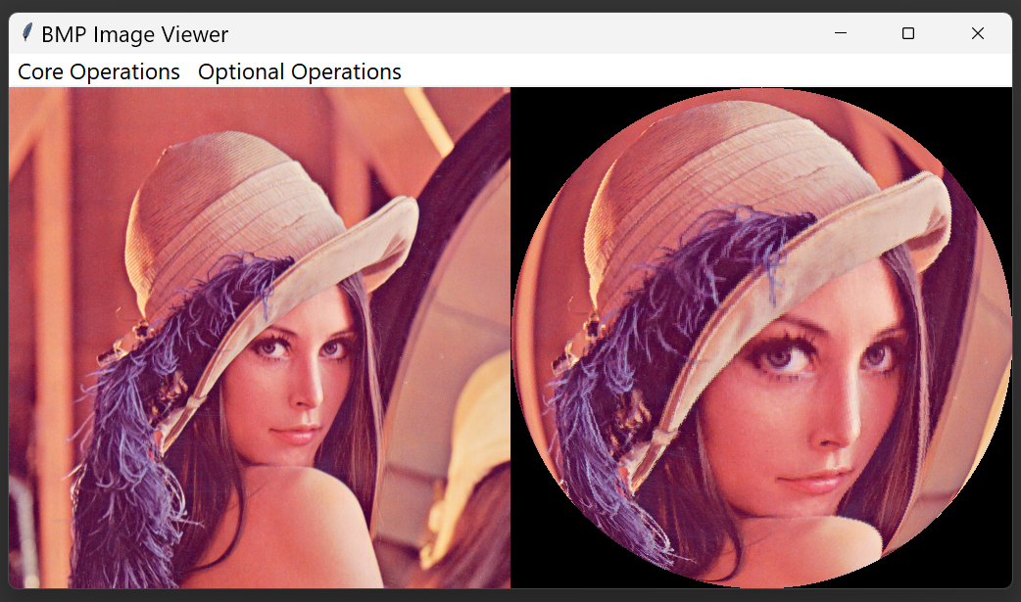

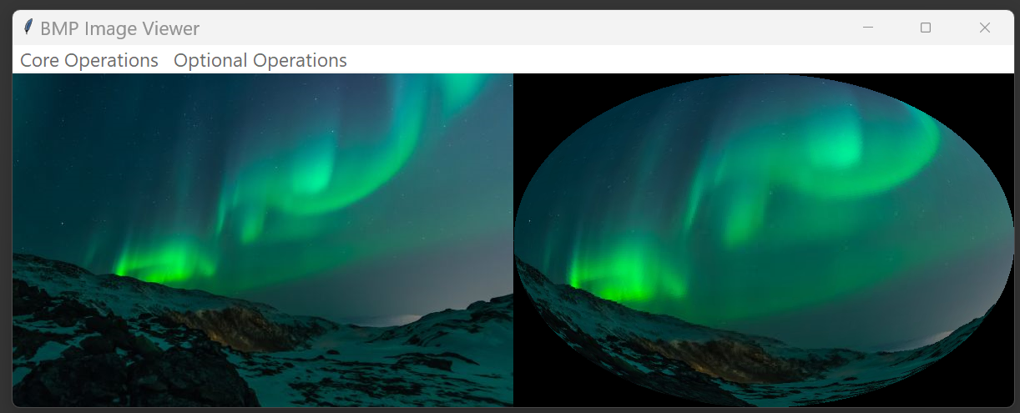

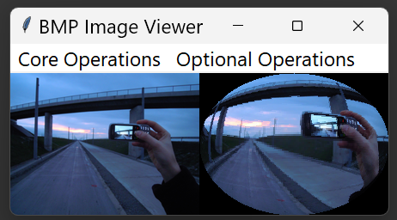

Figure 8 Sample Images After Fisheye Effect

***Mosaic Effect (adjustable) (default block size: 10)***

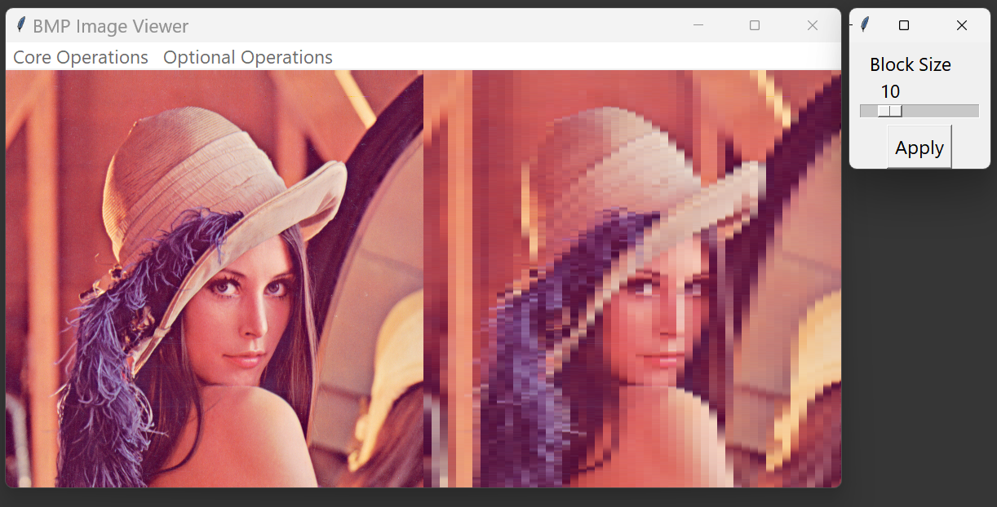

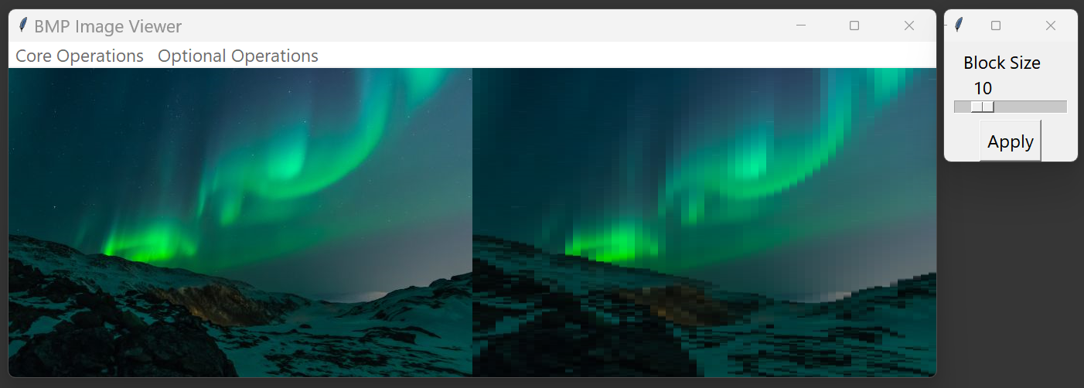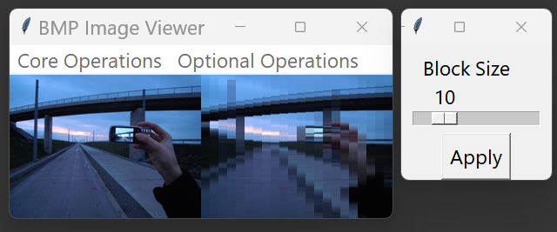

Figure 9 Sample Images After Mosaic Effect of block size = 10

***Mosaic Effect (adjustable) (varying block size of 3, 20, 50 using sample image 2)***

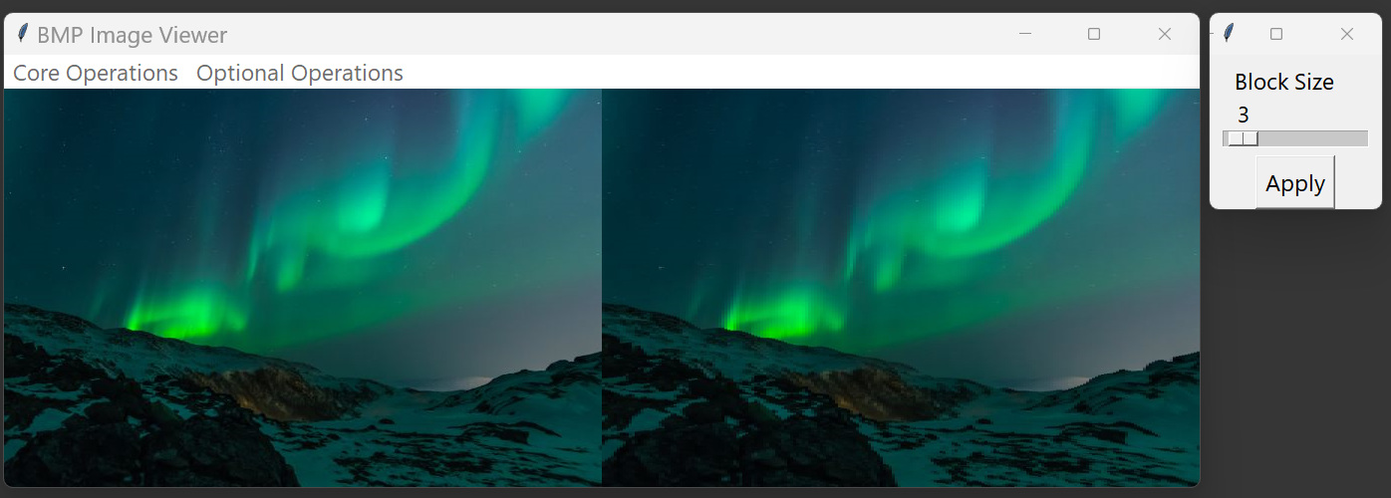 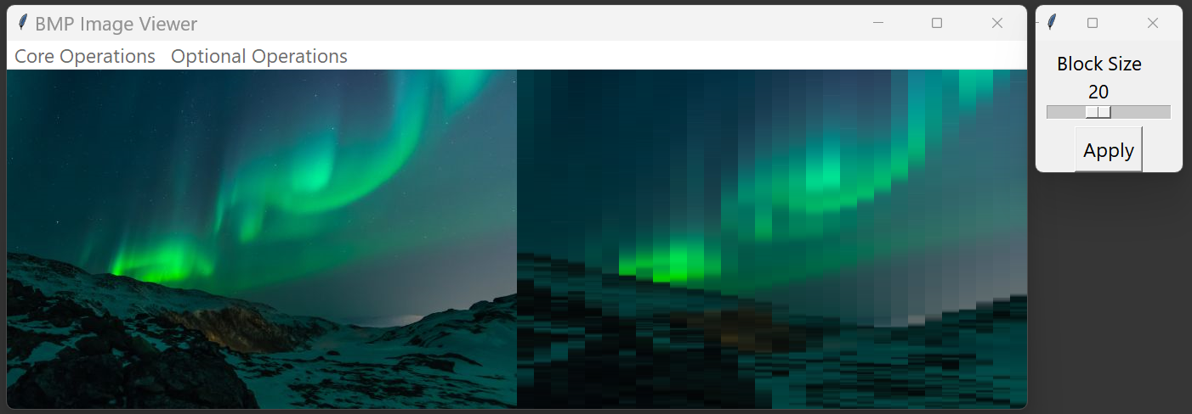

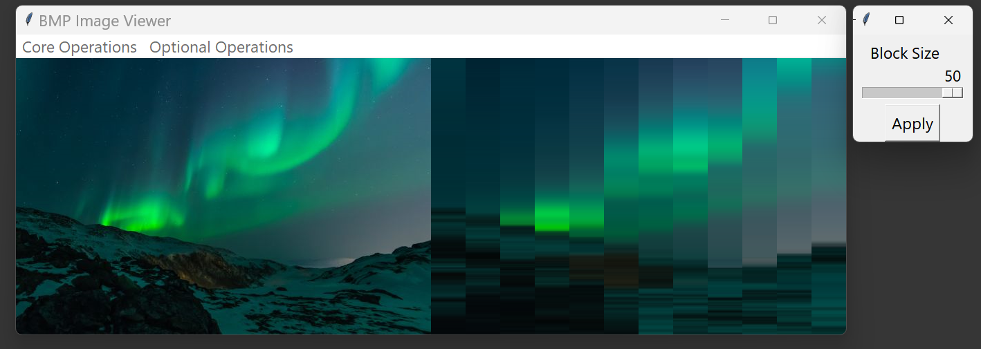

Figure 10 Sample Images After Mosaic Effect of block size = 3, 20, 50

***Sobel Edge Detection***

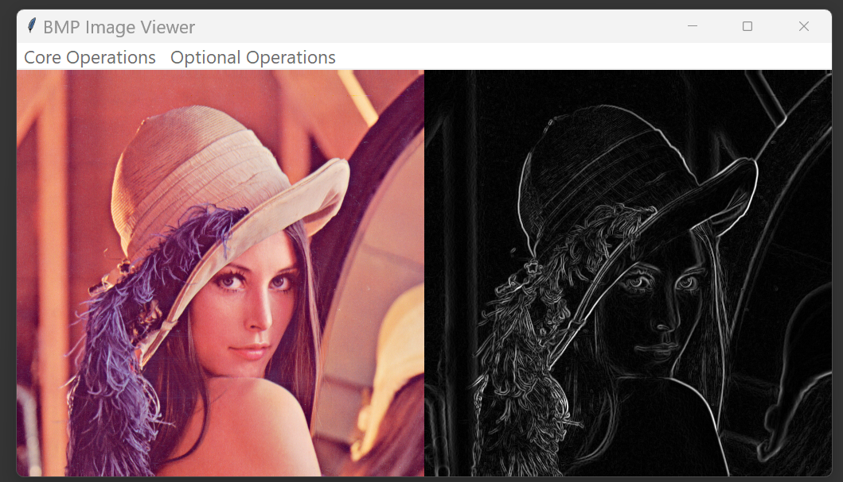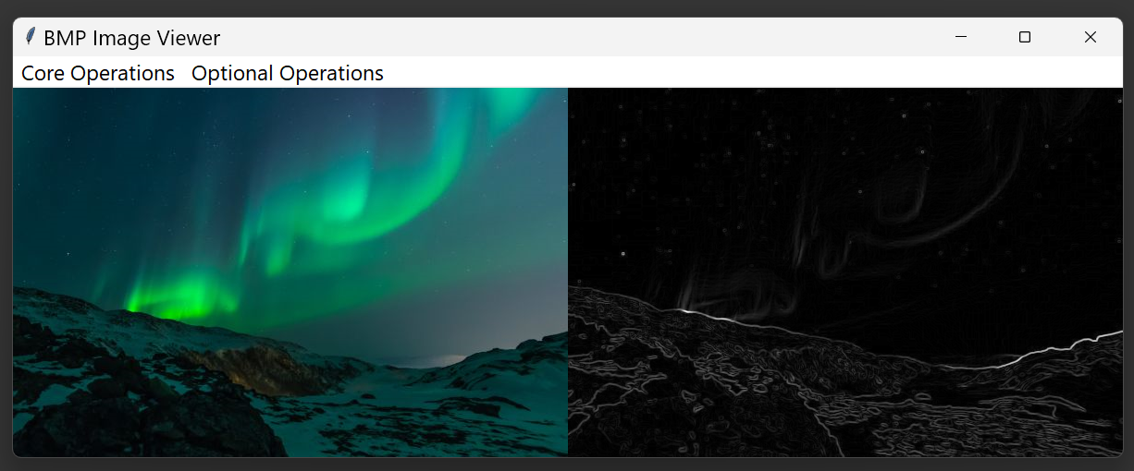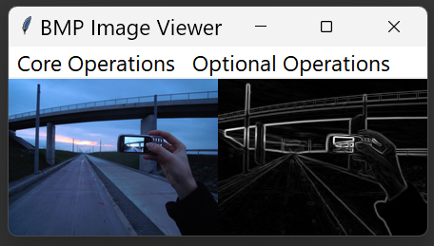

Figure 10 Sample Images After Sobel Edge Detection

***Canny Edge Detection***

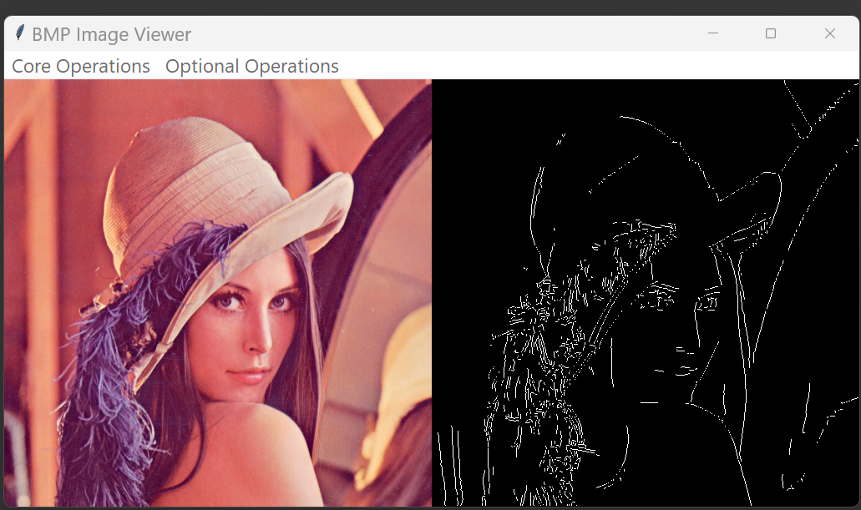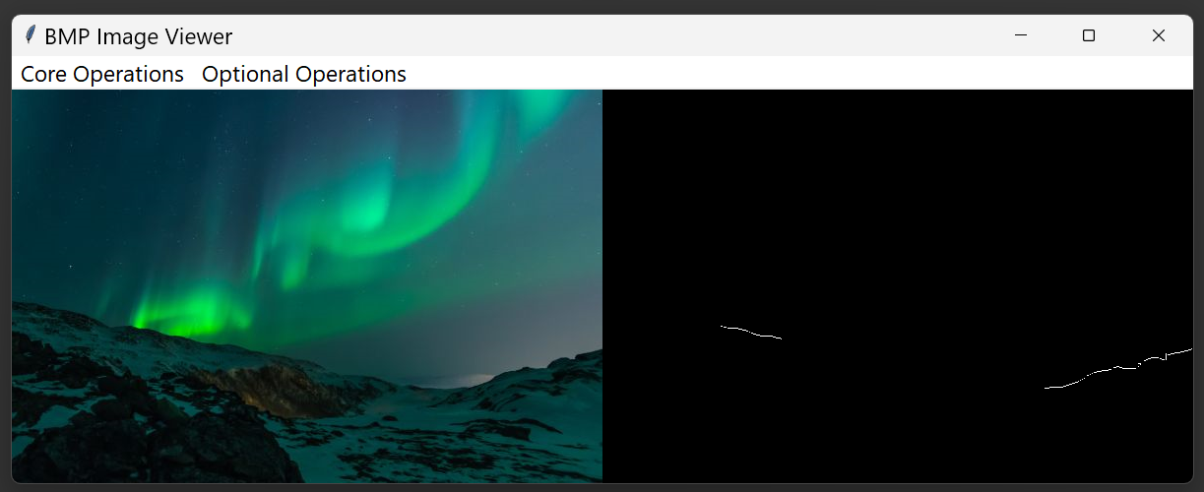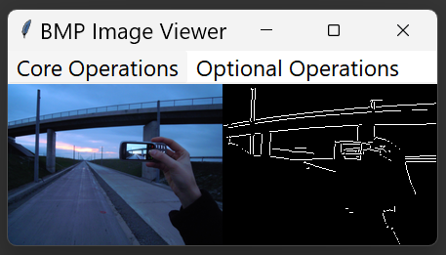

Figure 11 Sample Images After Canny Edge Detection

***Blur Image (adjustable) (default blur level (or kernel size): 5)***

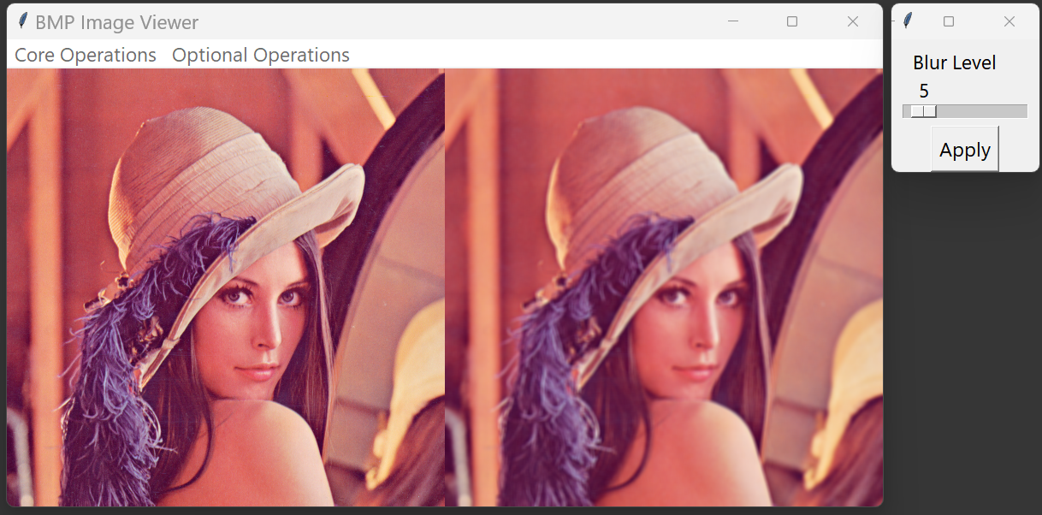

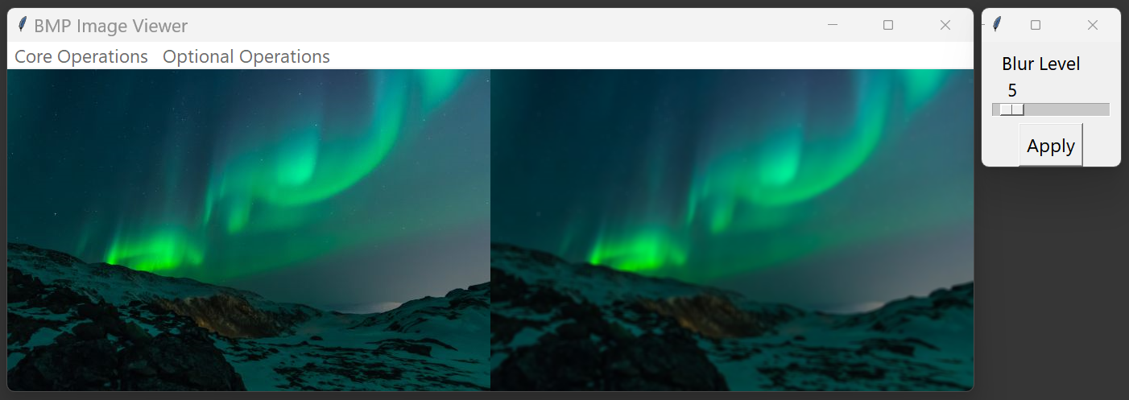

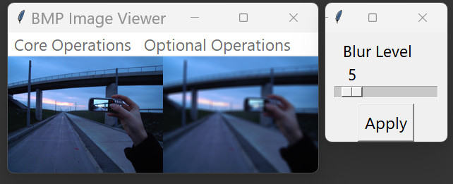

Figure 12 Sample Images After Blur Image

***Blur Image (adjustable) (using sample image 1, varying blur level (or kernel size): 3, 20, 50)***

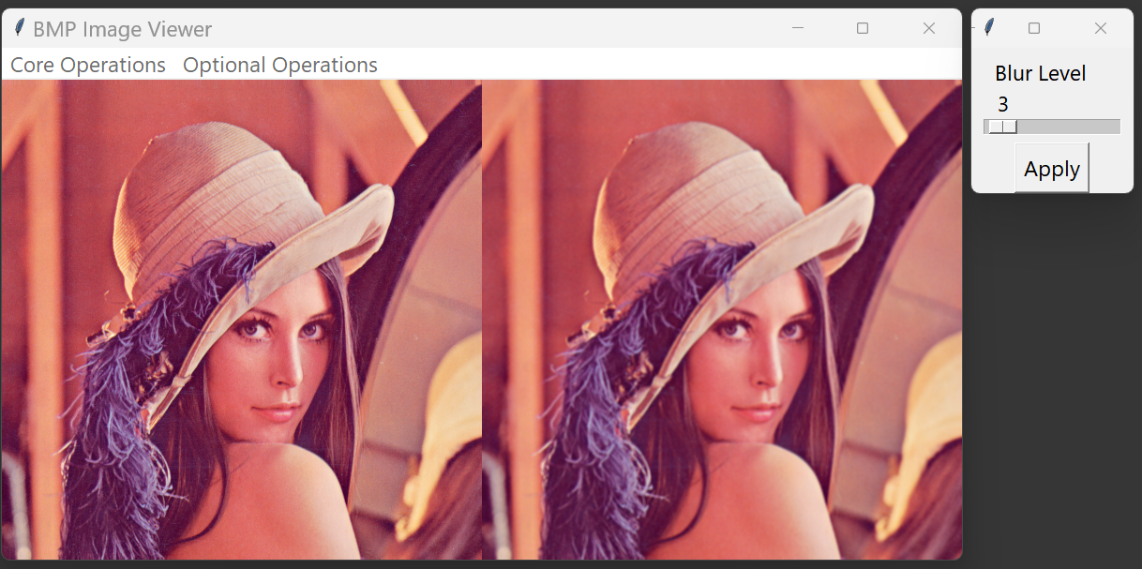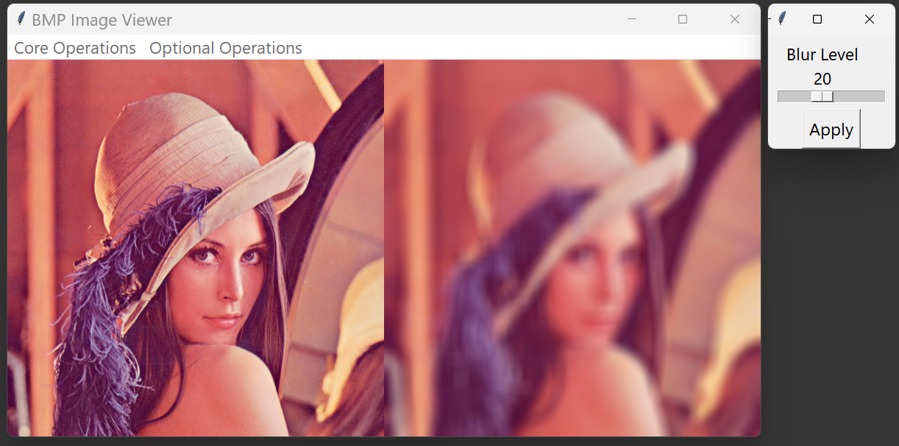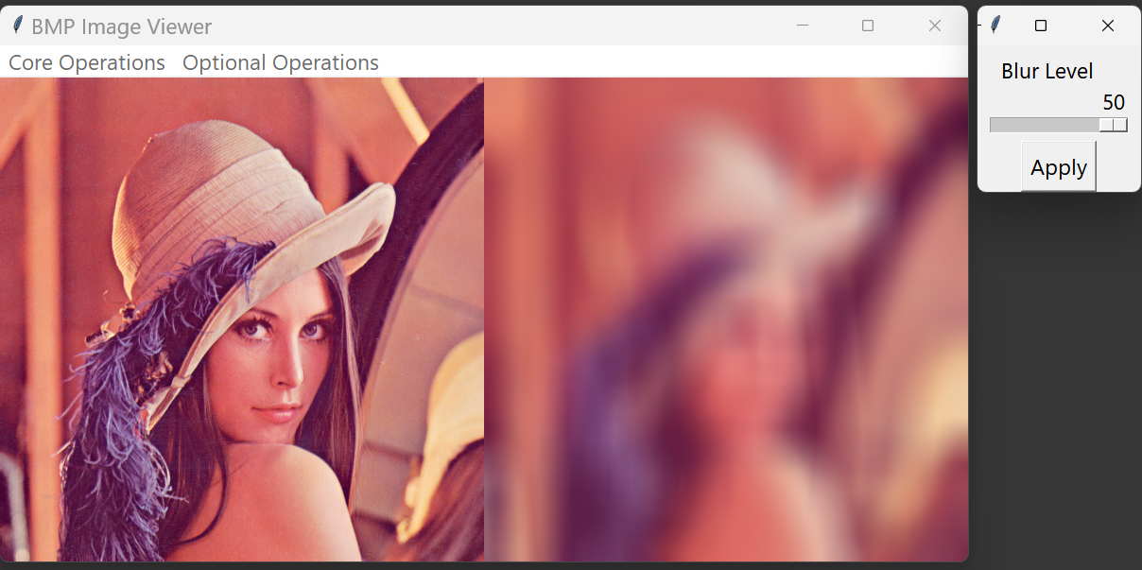

Figure 13 Sample Image 1 After Blur Image of kernel size of 3, 20, 50

***Histogram Normalization***

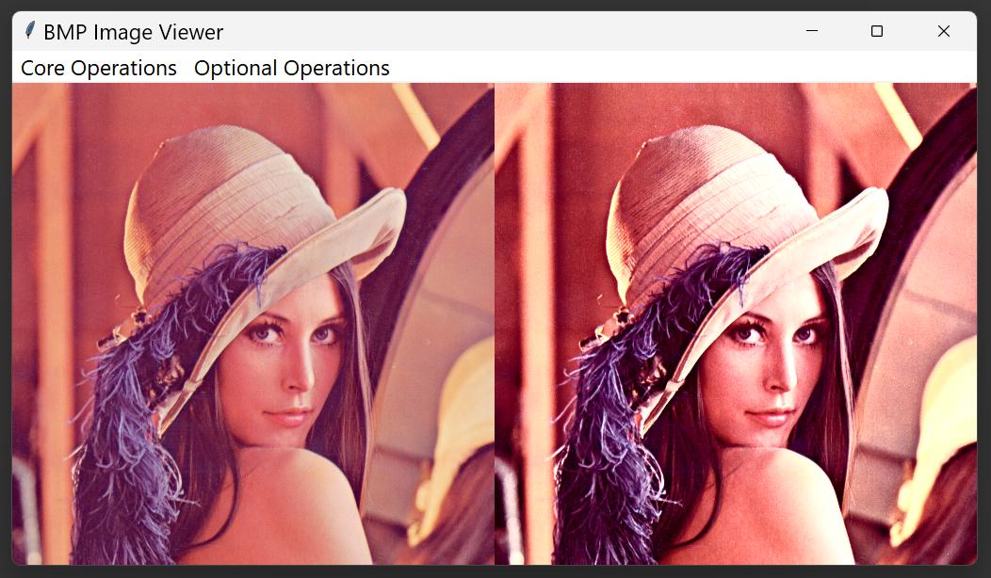

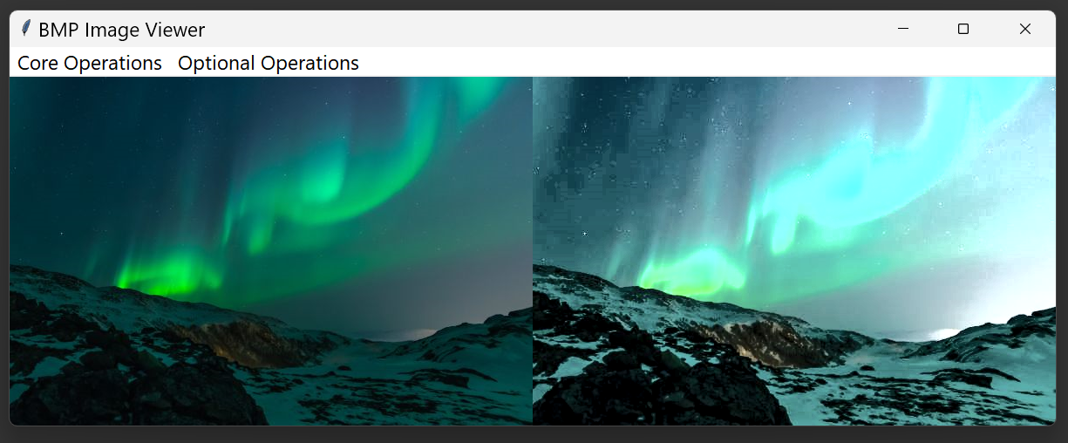

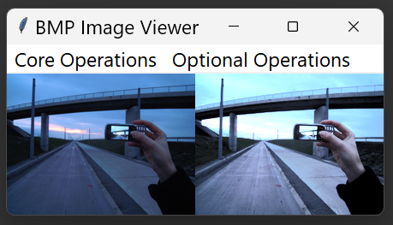

Figure 14 Sample Images After Histogram Normalization

**Unsharp masking (adjustable amount, radius, threshold) (default)**

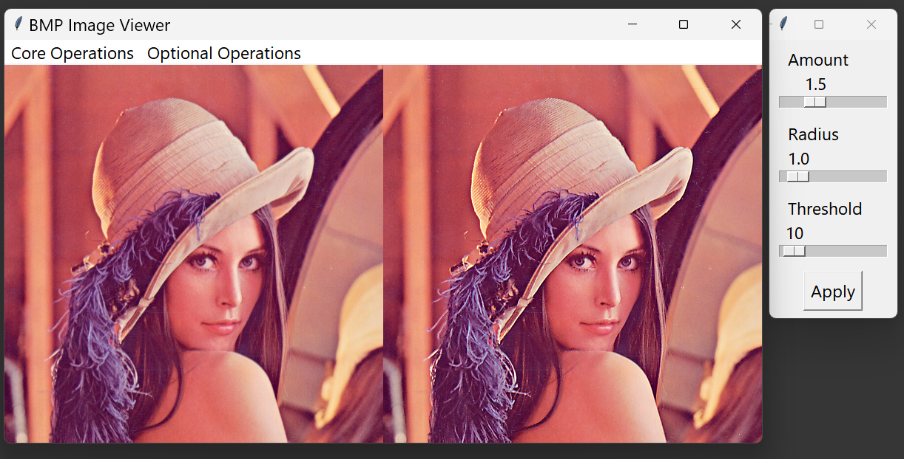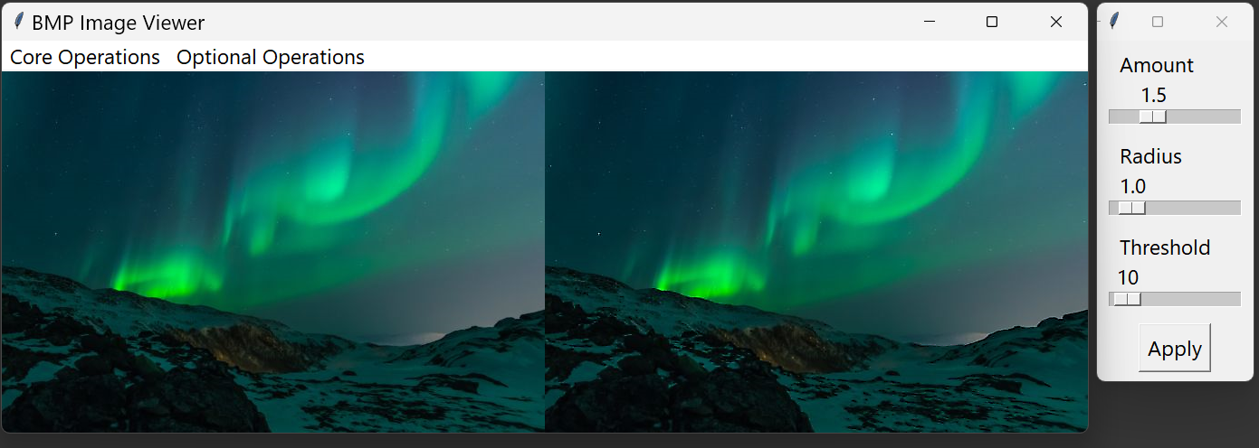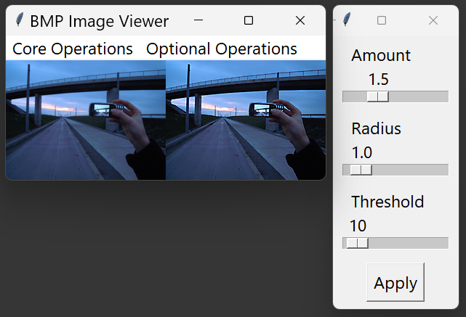

Figure 15 Sample Images After Unsharp Masking (default)

**Unsharp masking (using sample image 1, varying amount, radius, threshold)**

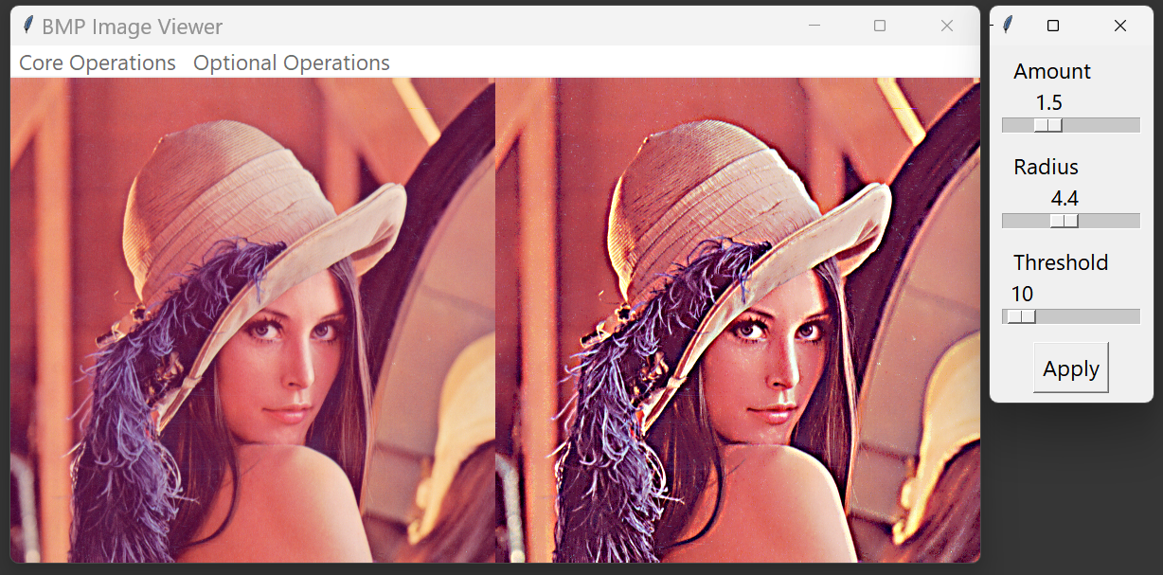

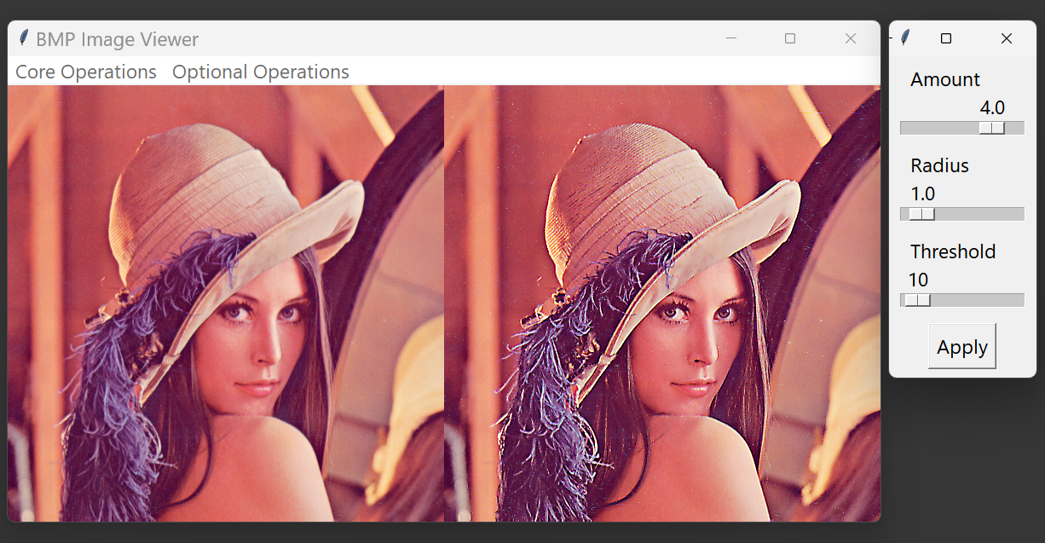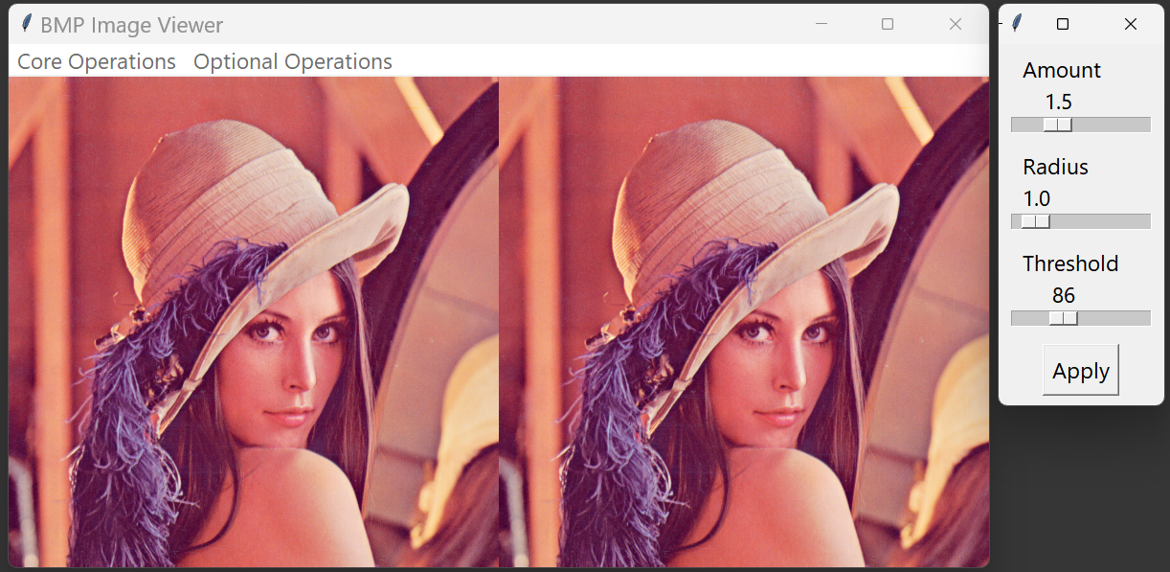

Figure 16 Sample Images After Unsharp Masking (varying parameters)

**Methods and Code Explanation**

**Core Methods**

***1. open_file***

This method lets the user select a BMP file to open:

* **Prompts the user to open a file** through filedialog.askopenfilename.
* **Calls display_image** if a valid file is selected.
* **Adds the optional menu** to the menu bar once an image is loaded, allowing access to additional effects.

***2. display_image***

Loads a BMP image and extracts pixel data:

* **Reads the BMP headers** to verify the image is a 24-bit uncompressed BMP and extracts relevant properties like width, height, and pixel data offset.
* **Reads and stores pixel data**, converting BGR format to RGB.
* **Adjusts the window size** based on image dimensions and calls display_tk_image to display the image.

***3. display_tk_image***

Displays the image in the Tkinter interface:

* **Creates a Tkinter PhotoImage object** based on image dimensions.
* **Loops through pixel data**, converting RGB values to hexadecimal color codes and placing each pixel in the PhotoImage.
* **Updates the image label** to display the new PhotoImage.

***4. display_side_by_side***

Displays two images side by side for comparison:

* **Creates a larger canvas** to accommodate both images horizontally.
* **Draws each image in sequence**, with the second image offset by the width of the first.
* **Updates the window size and image label** with the combined image.

**Core Transformation Methods**

***5. grayscale***

Converts the image to grayscale:

* **Applies a weighted average** (using 0.299, 0.587, and 0.114 for red, green, and blue, respectively) to each pixel to calculate a grayscale value.
* **Displays both the original and grayscale images** side by side using display_side_by_side.

***6. ordered_dithering***

Applies an ordered dithering effect to a grayscale image:

* **Converts the image to grayscale** using the same method as grayscale, but stores only the grayscale values.
* **Uses a Bayer matrix** to apply a dithering effect by comparing each pixel's grayscale value to a threshold in a 4x4 Bayer matrix:

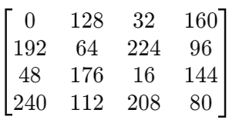

* **Determines the final color** for each pixel (black or white) based on its comparison to the matrix threshold.
* **Displays the original and dithered images** side by side.

***7. auto_level***

Enhances the image contrast by adjusting each color channel individually:

* **Finds the minimum and maximum values** for red, green, and blue channels across the entire image.
* **Applies scaling** to stretch each pixel's color values to the full range from 0 to 255:
$$new value=\frac{\left(current_{v}alue-min\right)×255}{max-min}$$

* **Displays both the original and auto-leveled images** side by side for comparison.

**Optional Transformation Methods**

***1. Invert Colors***

* **Method**: For each pixel in the image, we invert the RGB values by subtracting each color channel (R, G, B) from 255.
$$new color=255-original color$$

* **Implementation**: Iterate through each row and pixel, applying this formula to create a new list of inverted colors, then display the original and inverted images side-by-side.

***2. Sepia Tone***

* **Method**: Sepia tone applies a matrix transformation to RGB values:

$$tr = 0.393 ×R + 0.769 ×G + 0.189 ×B$$

$$tg = 0.349 ×R + 0.686 ×G + 0.168 ×B$$

$$tb = 0.272 ×R + 0.534 ×G + 0.131 ×B$$

Each resulting value is clamped between 0 and 255.

* **Implementation**: For each pixel, calculate the sepia RGB values and construct a new image.

***3. Fisheye Effect***

* **Method**: This effect is inspired by a blogpost on related topic (Jussi, 2014). It distorts the image, making the center pixels appear larger. The distortion uses polar coordinates and a radial transformation:

$$r=\sqrt{nx^{2}+ny^{2}}$$

$$nr=\frac{r+\left(1-\sqrt{1-r^{2}}\right)}{2}$$

where $\left(nx,ny\right)$ are normalized coordinates.

* **Implementation**: Convert each pixel’s location based on the distortion formula, then map each distorted pixel back to its new location in the image.

**4. Mosaic Effect (adjustable)**

* **Method:** Divide the image into blocks and set each pixel within a block to the average color of the block. Block size is set to 10 here.
  + Average Calculation: For each block, calculate the average of the red, green, and blue values.

$$avg color=\left(\frac{\sum{R}}{n},\frac{\sum{G}}{n},\frac{\sum{B}}{n}\right)$$

**5. Sobel Edge Detection**

* **Grayscale Conversion**: Convert each pixel to grayscale using the formula:
$$gray value=0.299*R+0.587*G+0.114*B$$

* **Gradient Calculation (Sobel Operators)**:
  + **Sobel X** kernel:
 $$sobel_{x} = \left[\left[-1, 0, 1\right],\left[-2,0,2\right],\left[-1,0,1\right]\right]$$

 + **Sobel Y** kernel:
 $$sobel_{y}=\left[\left[-1,-2,-1\right],\left[0,0,0\right],\left[1,2,1\right]\right]$$

 + **Gradient Magnitude**:
$$gradient magnitude=sqrt\left(gradient_{x}^{2}+gradient_{y}^{2}\right)$$

* **Normalization**: Normalize the gradient magnitude to the range [0, 255].

**6. Canny Edge Detection (inspired by blogpost showcasing the algorithm (Sofiane Sahir, 2019))**

* **Grayscale Conversion**: Convert each pixel to grayscale as above.
* **Gaussian Blur**: Apply a Gaussian filter for smoothing using:
$$gaussian kernal=\left[\left[1,2,1\right],\left[2,4,2\right],\left[1,2,1\right]\right]/16$$

* **Gradient Calculation**: Use Sobel operators to compute gradients along the x and y axes, then calculate gradient magnitude and direction:
$$gradient magnitude=sqrt\left(gradient_{x}^{2}+gradient_{y}^{2}\right)$$

$$gradient direction=atan2\left(gradient_{y},gradient_{x}\right)*180/pi$$

* **Non-Maximum Suppression**: Retain only the local maxima based on the gradient direction.
* **Double Thresholding**: Classify edges using a high and low threshold:
$$strong pixel=255$$

$$weak pixel=25$$

* **Edge Tracking by Hysteresis**: Convert weak pixels to strong pixels if they are connected to strong edges.

**7. Blur Image (adjustable)**

* **Blurring Kernel**: Use a box blur kernel with size 5x5:
$$kernel=ones\left(\left(5,5\right)\right)/25$$

* **Channel Blurring**: Convolve each color channel (R, G, B) with the kernel separately, then combine the blurred channels back.

**8. Histogram Equalization**

* **YCbCr Conversion**: Convert RGB to YCbCr color space:
$$Y = 0.299 * R + 0.587 * G + 0.114 * B$$

$$Cb = -0.168736 * R - 0.331264 * G + 0.5 * B + 128$$

$$Cr = 0.5 * R - 0.418688 * G - 0.081312 * B + 128$$

* **Histogram Calculation**: Flatten the Y channel, compute histogram, and find the cumulative distribution function (CDF).
* **Equalized Y Channel**: Use linear interpolation with the CDF to adjust pixel values in the Y channel.
* **Convert Back to RGB**: After equalization, convert the image back to RGB using the inverse YCbCr formula:

$$R=1.164*\left(Y-16\right)+1.596*\left(Cr-128\right)$$

$$G=1.164*\left(Y-16\right)-0.392*\left(Cb-128\right)-0.813*\left(Cr-128\right)$$

$$B=1.164*\left(Y-16\right)+2.017*\left(Cb-128\right)$$

**9. Unsharp masking (adjustable)**

***Unsharp Masking Process:***

* Parameters: Sharpening is controlled by three parameters:
  + Amount: The strength of the sharpening effect.
  + Radius: The radius of the Gaussian blur used to create the mask.
  + Threshold: Minimum brightness change required to apply sharpening.

***Gaussian Kernel Creation:***

* Kernel Calculation: The Gaussian kernel is computed with a size based on the radius, typically calculated as $6 * radius$ rounded up to the nearest odd integer
* Gaussian Function: Each element in the kernel is defined by the Gaussian function:
$$kernel\left[x,y\right]=e^{\left(-\left(x^{2}+y^{2}\right)/\left(2*sigma^{2}\right)\right)}$$

* Normalization: The kernel values are normalized so that their sum is 1.

***Image Sharpening:***

* Channel Processing: For each RGB channel, a Gaussian blur is applied using the generated kernel. The original channel value is subtracted from the blurred version to create a mask:
$$mask = original_channel - blurred_channel$$

* Thresholding: Mask values smaller than the threshold are set to zero to avoid sharpening minor variations.
* Mask Application: The mask is then scaled by the amount parameter and added back to the original channel to enhance the image:
$$sharpened_channel = original_channel + amount * mask$$

* Clipping: Values are clipped to remain in the range of [0,255] to fit the RGB format.

***Interactive Sliders****:*

* Slider Window: The interface provides sliders for each parameter (amount, radius, threshold) to dynamically adjust the effect.

**Discussions and insights**

During this project, I delved deeper into image processing techniques, building upon the GUI knowledge I had gained from Project 1. The focus was primarily on learning and implementing various image processing algorithms. Here are some key insights and challenges:

**Core operations:**

***Grayscale Conversion***

The grayscale conversion used the standard weighted sum formula (0.299R + 0.587G + 0.114B), which accurately represents human perception of brightness across different color channels.

***Ordered Dithering***

For ordered dithering, I initially implemented the basic 4x4 Bayer matrix as discussed in class. However, during the project, I discovered and experimented with various other dithering matrices. For example:

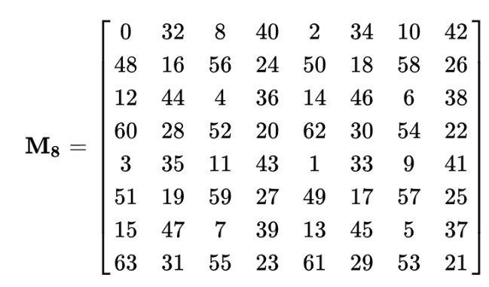

Testing different matrices revealed interesting variations in the dithered output. Some matrices produced finer grain patterns, while others resulted in more pronounced textures.

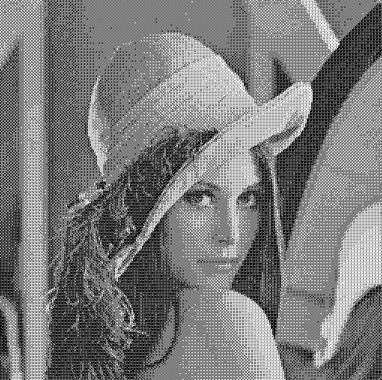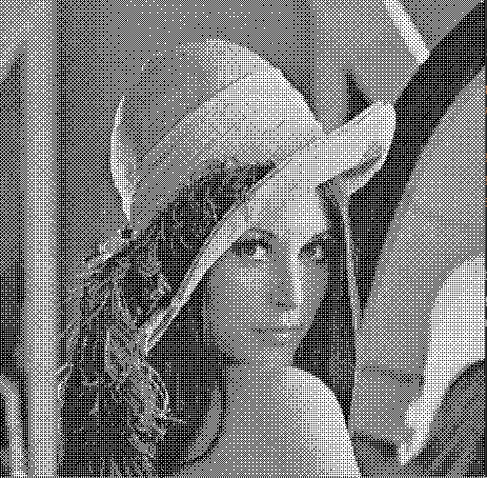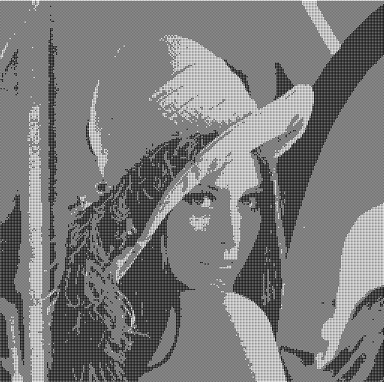

Figure 17 Testing with 2*2, 4*4, 8*8 Bayers Matrix Respectively

Some observations from the experiment:

* 2x2 Matrix:  
  • Exhibits the most pronounced and coarse dithering pattern  
  • Results in significant loss of image detail  
  • Pattern repetition is highly noticeable and can be visually distracting
* 4x4 Matrix:  
  • Provides an effective balance between pattern visibility and detail retention  
  • Dithering pattern is less conspicuous than 2x2, yet still discernible  
  • Preserves more image nuances compared to the 2x2 matrix
* 8x8 Matrix:  
  • Produces the most refined dithering pattern among the three options  
  • Retains the highest level of detail from the original image  
  • Dithering pattern is least perceptible to the human eye, resulting in smoother appearance

Conclusion:  
The choice of dithering matrix size presents a trade-off between processing complexity and image quality, with larger matrices generally yielding superior results at the cost of increased computational demands.  
***Auto Leveling***

For the auto leveling implementation, we chose an approach that focuses on stretching the histogram to utilize the full range of pixel values. This method was selected for its effectiveness and relative simplicity. Here's a breakdown of the approach:

1. **Histogram Analysis**: We first analyze the histogram of each color channel (R, G, B) to find the minimum and maximum pixel values used in the image.
2. **Range Stretching**: Using these min and max values, we then stretch this range to cover the full 0-255 spectrum
3. **Per-Channel Processing**: By applying this stretching to each channel independently, we ensure that color balance is maintained while improving overall contrast.

This approach was chosen over more complex methods (like histogram equalization) for several reasons:

* 1. **Simplicity**: It's straightforward to implement and understand.
  2. **Effectiveness**: It significantly improves contrast in most images without introducing artifacts.
  3. **Preservation of Relative Brightness**: Unlike histogram equalization, this method maintains the relative brightness relationships between pixels.

**Optional Operations**

In implementing the optional operations, I adopted a strategic approach, starting with simpler color manipulations and gradually moving to more complex spatial transformations. This progression allowed for a deeper understanding of image processing techniques at various levels of complexity.

**Color Manipulation Filters**

I began with color manipulation filters that operate on individual pixels:

1. **Invert Colors**: This was the simplest operation, involving a straightforward subtraction of each color channel from 255. It provided a good starting point to understand pixel-level manipulations.
2. **Sepia Tone**: This filter introduced the concept of color mixing. The implementation involved a weighted sum of the original RGB values to create a new color palette. It was fascinating to see how adjusting these weights could dramatically change the mood of an image.

***Insights from Color Manipulations***

* The simplicity of these operations belies their visual impact. It was intriguing to see how such straightforward mathematical operations could create dramatic visual effects.
* These filters highlighted the importance of color theory in image processing. The sepia tone demonstrated how certain color combinations can evoke specific emotional responses or historical contexts.

***Insights from Spatial Transformations***

The fisheye effect implementation was particularly enlightening, offering several valuable insights:

* **Mathematical Complexity**: The effect demonstrated how complex mathematical transformations can create visually striking results. The conversion between Cartesian and polar coordinates, coupled with non-linear distortion functions, highlighted the intricate relationship between mathematics and visual perception
* **Edge Case Handling**: A significant challenge arose in handling pixels near the image borders, where the warping effect is most pronounced. This led to deeper considerations about interpolation techniques and strategies for handling pixels that map outside the original image boundaries. These edge cases are crucial in maintaining the illusion of a seamless fisheye effect.
* **Lens Distortion Simulation**: Implementing this effect provided insights into the principles of lens distortion in photography. It was fascinating to see how software can accurately simulate optical effects that are typically achieved through specialized hardware.
* **Non-Square Image Adaptation**: An interesting observation was that our implementation successfully handled non-square images, resulting in oval-shaped fisheye effects, as highlighted in Figure 8. This aligns with mathematical predictions and mirrors the behavior of physical fisheye lenses on different sensor formats.

**Edge Detection Algorithms**

My exploration of image processing techniques began with kernel convolution for filtering, which led to the implementation of the blurring and later Sobel edge detection algorithm. This foundational step sparked my interest in more advanced edge detection methods, ultimately leading to the Canny edge detection algorithm (Canny, 1986)

***Sobel Edge Detection***

The Sobel algorithm provided a straightforward approach to edge detection, involving:

1. Grayscale Conversion: The original image is converted to grayscale to simplify the edge detection process.
2. Gradient Calculation: Sobel operators are applied to compute gradients in both x and y directions.
3. Magnitude Normalization: The gradient magnitudes are normalized to a range of 0-255 for visualization.

While effective, Sobel's method can miss subtle edges and is sensitive to noise (Gonzalez & Woods, 2018)

***Canny Edge Detection***

Upon researching more powerful algorithms, I implemented the Canny edge detection method, which incorporates several post-processing steps:

1. Gaussian Blur: This initial step reduces noise, improving edge detection accuracy.
2. Gradient Calculation: Similar to Sobel, but with enhanced sensitivity due to prior blurring.
3. Non-Maximum Suppression: This step thins edges but can lead to the loss of weak edges that may be significant in low-contrast images.
4. Double Thresholding: Differentiates between strong and weak edges; however, many weak edges may not connect to strong ones, resulting in further detail loss.
5. Edge Tracking by Hysteresis: Finalizes edge determination but may fail to retain important weak edges.

***Challenges and Observations***

The implementation of Canny edge detection revealed both strengths and limitations when compared to the Sobel method. While Canny often produces cleaner results, it can overlook critical details in images with subtle edges. The process of classifying edges into strong and weak categories can inadvertently lead to important features being categorized as weak and subsequently discarded (Ding & Goshtasby, 2001).

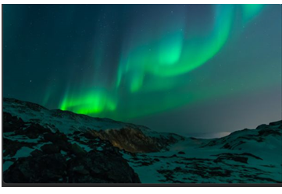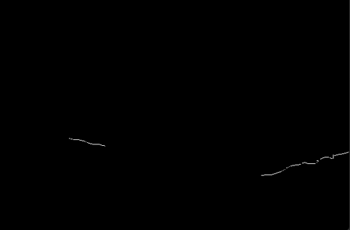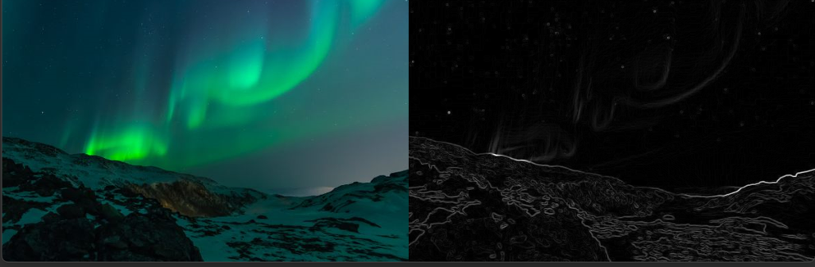 This phenomenon is particularly evident when comparing Figures 10 and 11, specifically in the middle photo featuring a dark snow-covered mountain. To better illustrate this difference, let's examine a direct comparing version of these images with the highlighted area:

Figure 20 Sample Photo 2 After Canny’s Method

Figure 18 Original Sample Photo 2

Figure 19 Sample Photo 2 After Sobel’s Method

In the Sobel result (Figures 16), the low-contrast areas (indicated by the red rectangle) of the mountain are represented by grey edges, indicating detection of subtle gradients. However, in the Canny result (Figures 17), these edges are completely absent. This occurs because the post-processing steps in Canny's method, particularly the hysteresis thresholding, eliminate weak edges that are not connected to strong edges. The disadvantage of Canny's method in low-contrast areas is further demonstrated in the red rectangular area in the third sample image in Figure 19 and 20, where the details of the road ahead are preserved in the Sobel results but are largely absent in 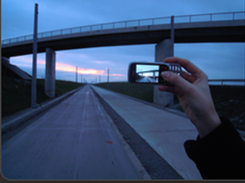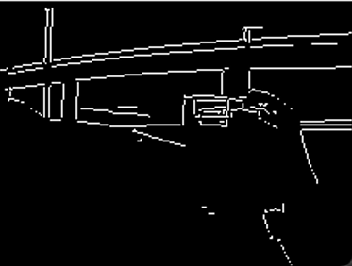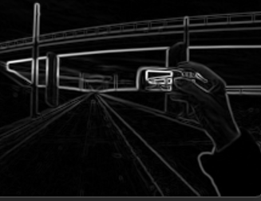the Canny output.

Figure 21 Original Sample Photo 3

Figure 23 Sample Photo 3 After Canny's Method

Figure 22 Sample Photo 3 After Sobel's Method

This comparison highlights a key trade-off: while Canny often produces cleaner and more defined edges in high-contrast areas, it may struggle to retain important details in regions with subtle gradients. In summary, these observations underscore the importance of selecting the appropriate edge detection method based on the specific characteristics of the input image and the desired output. While Canny excels in producing clean, well-defined edges in high-contrast scenarios, Sobel may be preferable for preserving subtle details in low-contrast areas.

**Image Enhancement Techniques**

***Histogram Equalization Implementation***

My initial approach to histogram equalization focused on grayscale images. However, when attempting to extend this method to color images by applying it to individual RGB channels, I encountered unexpected results. This led to a deeper understanding of color spaces and their role in image processing. The solution involved converting the image from RGB to YCbCr color space:

1. Isolating the Y channel (luminance)
2. Applying histogram equalization specifically to this channel
3. Converting the image back to RGB format

This process not only solved the initial problem but also deepened my understanding of how different color representations can be leveraged for specific image enhancement goals (Gonzalez & Woods, 2018).

***Comparison with Auto Level Adjustment***

To gain a more comprehensive understanding of image enhancement techniques, I also implemented and compared the results with auto level adjustment. The comparison revealed interesting differences:

1. Color Preservation:
   * Histogram Equalization: Better preserves original color relationships, maintaining a more natural look.
   * Auto Level: Can sometimes produce color shifts, leading to less accurate color representation.
2. Contrast Enhancement:
   * Histogram Equalization: Provides a more uniform contrast distribution but can sometimes lead to over-exposure and loss of fine details in bright areas.
   * Auto Level: Often results in stronger overall contrast, preserving more details in both highlights and shadows.
3. Detail Retention:
   * Histogram Equalization: May lose some fine details in over-exposed areas due to its focus on overall distribution.
   * Auto Level: Generally better at retaining fine lighting details across the image.

***Algorithm Differences Explaining Results***

The observed differences can be attributed to the fundamental approaches of these algorithms:

1. Histogram Equalization:
   * Works by redistributing pixel intensities to achieve a more uniform histogram.
   * Operates on the luminance channel in YCbCr space, preserving color relationships.
   * Can sometimes "push" many pixels towards the extremes of the intensity range, leading to potential detail loss in very bright or dark areas (Pizer et al., 1987).
2. Auto Level Adjustment:
   * Typically involves stretching the histogram to cover the full intensity range.
   * Often applies this stretching to each RGB channel independently, which can lead to color shifts but also to better preservation of channel-specific details.
   * More effective at enhancing local contrast, as it's not constrained by trying to achieve a uniform distribution (Gonzalez & Woods, 2018).

These algorithmic differences explain why histogram equalization tends to preserve overall color appearance better (by only modifying luminance), while auto level adjustment often produces images with more pronounced contrast and detail visibility, albeit sometimes at the cost of color accuracy.

**Unsharp Masking**

In implementing image sharpening, I chose to focus on the Unsharp Masking (USM) technique, which is widely recognized as one of the most effective and commonly used methods for enhancing image detail’s is particularly appealing due to its relative ease of implementation and the high-quality results it produces. The method considers various factors that influence image sharpness, making it a versatile choice for different types of images.

To ensure a user-friendly interface, I modeled the implementation after Adobe Photoshop's USM filter, which utilizes three key parameters: Amount, Radius, and Threshold3. This approach provides users with familiar controls while offering fine-grained adjustment capabilities.

The technical implementation of these parameters in the code is as follows:

* 1. Amount: This parameter controls the strength of the sharpening effect. In the code, it's implemented as a multiplier for the mask (amount * mask), allowing users to adjust the intensity of the edge enhancement.
  2. Radius: This determines the size of the edges to be enhanced. It's used to create a Gaussian kernel for blurring, which is crucial in detecting edges. The code dynamically generates this kernel based on the user-specified radius.
  3. Threshold: This sets the minimum brightness change to be sharpened, helping to avoid amplifying noise. In the implementation, it's used to create a mask where pixels with changes below the threshold are set to zero.

The sharpening process involves creating a blurred version of the image using the Gaussian kernel, subtracting this from the original to create a mask, and then adding this mask back to the original image with the specified amount. The use of convolution (convolve2d) for applying the Gaussian blur ensures efficient and accurate edge detection.

By providing interactive sliders for these parameters, users can fine-tune the sharpening effect in real-time, observing the changes and achieving the desired level of enhancement for their specific image.

**Conclusion**

This exploration into various image processing techniques, from edge detection to contrast enhancement, has provided valuable insights into the complexities and trade-offs inherent in different algorithms. Each method offers unique strengths and limitations, underscoring the importance of selecting appropriate techniques based on specific image characteristics and desired outcomes. The journey through implementing and comparing these algorithms has not only enhanced technical skills but also deepened understanding of the fundamental principles underlying image processing and enhancement.

**Reference**

Canny, J. (1986). A Computational Approach to Edge Detection. *IEEE Transactions on Pattern Analysis and Machine Intelligence*, *PAMI-8*(6), 679–698. https://doi.org/10.1109/tpami.1986.4767851

Ding, L., & Goshtasby, A. (2001). On the Canny edge detector. *Pattern Recognition*, *34*(3), 721–725. https://doi.org/10.1016/s0031-3203(00)00023-6

Gonzalez, R. C., & Woods, R. E. (2018). *Digital image processing* (4th ed.). Pearson.

Jussi. (2014). *Fisheye lens equation - Simple fisheye effect with one function*. Blogspot.com. https://popscan.blogspot.com/2012/04/fisheye-lens-equation-simple-fisheye.html

Pizer, S. M., Amburn, E. P., Austin, J. D., Cromartie, R., Geselowitz, A., Greer, T., ter Haar Romeny, B., Zimmerman, J. B., & Zuiderveld, K. (1987). Adaptive histogram equalization and its variations. *Computer Vision, Graphics, and Image Processing*, *39*(3), 355–368. https://doi.org/10.1016/S0734-189X(87)80186-X

Sofiane Sahir. (2019, January 25). *Canny Edge Detection Step by Step in Python — Computer Vision*. Towards Data Science; Towards Data Science. https://towardsdatascience.com/canny-edge-detection-step-by-step-in-python-computer-vision-b49c3a2d8123